CAREER GUIDANCE FOR EDUCATION
A Real-Time Research Project Report
submitted to JNTU Hyderabad in partial fulfillment
of the requirements for the award of the degree

BACHELOR OF TECHNOLOGY
In
COMPUTER SCIENCE AND ENGINEERING
Submitted by

MALKAPURE SRAVANI 22RG1A05A4

HANMANTHOLLA ESHWARI 22RG1A0588

SANDEPAGA CHANDRAKALA 22RG1A05C0

PANYALA ALEKHYA 22RG1A05B0

Under the Guidance of
Mrs. N.SUNEETA
B. Tech., M. Tech
Assistant Professor

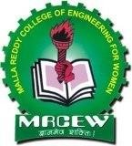

DEPARTMENT OF COMPUTER SCIENCE & ENGINEERING
MALLA REDDY COLLEGE OF ENGINEERING FOR WOMEN
An UGC Autonomous Institution
Approved by AICTE New Delhi and Affiliated to JNTUH
An ISO 9001: 2015 Certified Institution
B. Tech. Programs CSE, ECE Accredited by NBA
IIC 5.0 with 4-star Rating; INDIAN RANKINGS 2023 NIRF Innovation Band151-300 Maisammaguda , Medchal (Dist), Hyderabad -500100, Telangana.
JUNE 2024
i

DEPARTMENT OF COMPUTER SCIENCE & ENGINEERING
MALLA REDDY COLLEGE OF ENGINEERING FOR WOMEN
An UGC Autonomous Institution
Approved by AICTE New Delhi and Affiliated to JNTU
An ISO 9001: 2015 Certified Institution
B. Tech. Programs CSE, ECE Accredited by NBA
IIC 5.0 with 4-star Rating; INDIAN RANKINGS 2023 NIRF Innovation Band151-300 Maisammaguda , Medchal (Dist), Hyderabad -500100, Telangana.
JUNE 2024

CERTIFICATE

This is to certify that the Real-Time Research Project entitled “CAREER GUIDANCE FOR EDUCATION” has been submitted by MALKAPURE SRAVANI (22RG1A05A4), HANMANTHOLLA ESHWARI (22RG1A0588) ,SANDEPAGA CHANDRAKALA (22RG1A05C0) , PANYALA ALEKHYA (22RG1A05B0) in partial fulfillment of the requirements for the award of BACHELOR OF TECHNOLOGY in COMPUTER SCIENCE & ENGINEERING. This record of bonafide work carried out by them under my guidance and supervision. The result embodied in this Real-Time Research Project report has not been submitted to any other University or Institute for the award of any degree.

Mrs. N.SUNEETA Mrs. K. SHEETAL
Project Guide Head of the Department

External Examiner

ACKNOWLEDGEMENT

The Real-Time Research Project work carried out by our team in the Department of Computer Science and Engineering, Malla Reddy College of Engineering for Women, Hyderabad. This work is original and has not been submitted in part or full for any degree or diploma of any other university.
We wish to acknowledge our sincere thanks to our project guide Mrs. N.Suneeta, Assistant Professor, Computer Science & Engineering for formulation of the problem, analysis, guidance and her continuous supervision during the course of work.
We acknowledge our sincere thanks to Dr.Kanaka Durga Returi, Principal & Professor of Department of Computer Science and Engineering and Mrs. Sheetal Kulkarni, Head of the Department, MRCEW and all our faculties of CSE Department for their kind cooperation in making this Real-Time Research Project work a success.
We extend our gratitude to Sri. Ch. Malla Reddy, Founder Chairman and Sri. Ch. Mahender Reddy, Secretary, Dr. Vaka Murali Mohan, Director for their kind cooperation in providing the infrastructure for completion of our Real-Time Research Project.
We acknowledge our special thanks to the entire teaching faculty and non-teaching staff members of the Computer Science & Engineering Department for their support in making this project work a success.

Malkapure Sravani 22RG1A05A4
Hanmantholla Eshwari 22RG1A0588
Sandepaga Chandrakala 22RG1A05C0
Panyala Alekhya 22RG1A05B0

INDEX

Chapter ABSTRACT  LIST OF FIGURES  1. SYSTEM ANALYSIS | Page No.  vii viii  1
1.1 Existing System | 1
1.1.1 Disadvantages of Existing System | 2
1.2 Proposed System | 3
1.2.1 Advantages of Proposed System | 4
1.3 Introduction | 4
2. LITERATURE SURVEY | 6
3. SYSTEM DESIGN | 10
3.1 System modules | 10
3.1.1 Server | 10
3.1.2 User | 10
3.2 System Requirements | 11
3.2.1 Hardware Requirements | 11
3.2.2 Software Requirements | 11
3.3 UML Diagrams | 12
3.3.1 Use Case Diagram | 12
3.3.2 Class Diagram | 13
3.3.3 Sequence Diagram | 14
3.3.4 Flow Chart Diagram | 15

4. INPUT & OUTPUT DESIGN 16
4.1 Input Design 16
4.2 Output Design 17
5. SOFTWARE ENVIRONMENT 18
5.1 Java Technology 18
5.1.1 Java as Programming Language 18
    - Java Platform 19
5.1.3 What Can Java Technology Do? 20
5.1.4 How Will Java Technology Change My Life? 22
5.2 JDBC 24
5.2.1 JDBC Goals 25
  - Networking 26
5.3.1 TCP/IP Stack 28
5.3.2 IP Datagram’s 28
5.3.3 UDP 28
5.3.4 TCP 29
5.4 Sockets 30
5.5 J2ME 31
    - General J2ME Architecture 31
    - Developing J2ME Architecture 31
    - Design Consideration for Small Devices 32
    - Configuration Overview 32
    - J2ME Profiles 32
6. SYSTEM STUDY 33
  - Economic Feasibility 33
  - Technical Feasibility 33
  - Social Feasibility 34
7. SYSTEM TESTING 35
  - Types of Tests 35
7.1.1 Unit testing 35
    - Integration testing 35
    - Functional testing 35
    - System testing 36
    - Acceptance testing 37
- RESULTS 39
- CONCLUSION & FUTURE ENHANCEMENT 44
10.BIBLIOGRAPHY 45

ABSTRACT
In the dynamic landscape of modern education, empowering individuals with informed career decisions is paramount. This abstract presents an innovative project aimed at revolutionizing career guidance through an online platform. The project seeks to address the challenges faced by students and professionals in navigating their educational and professional trajectories effectively. The proposed platform integrates cutting-edge technology with comprehensive career resources to offer personalized guidance tailored to individual aspirations and aptitudes. Leveraging artificial intelligence algorithms, the platform analyzes user profiles, including academic records, interests, and skills, to generate customized career recommendations. Key features of the platform include interactive career assessments, virtual mentorship programs, and real-time job market insights. Users can explore various career paths, access educational resources, and connect with industry experts seamlessly. Additionally, the platform fosters community engagement through discussion forums and networking opportunities, facilitating peer-to-peer learning and collaboration. Through this project, we aim to democratize access to career guidance, particularly for underserved populations and remote communities. By harnessing the power of technology, we envision empowering individuals worldwide to make informed decisions about their educational and professional futures, ultimately fostering a more inclusive and prosperous society.
Top of Form
Bottom of Form

vii

LIST OF FIGURES
Fig. No. Fig. Name Page.no

3.1 | System Architecture | 11
3.2 | Use Case Diagram | 12
3.3 | Class Diagram | 13
3.4 | Sequence Diagram | 14
3.5 | Flow Chart Diagram | 15
3.5.1 | Flow Chart Diagram | 15
3.6 | Data Flow Diagram | 16
8.1 | Screenshot of Home Page | 39
8.2 | Screenshot of User Login Page | 39
8.3 | Screenshot of User Registration | 40
8.4 | Screenshot of Course Information | 40
8.5 | Screenshot of List of Courses | 41
8.6 | Screenshot of Job Information | 41
8.7 | Screenshot of Placement Details | 42
8.8 | Screenshot of Course Information | 42
8.9 | Screenshot of Feedback Form | 43
8.10 | Screenshot of Forgot Password | 43
 | viii

CHAPTER-1: SYSTEM ANALYSIS

  - EXISTING SYSTEM
- Existing online career guidance systems encompass a diverse array of platforms and services aimed at assisting individuals in making informed decisions about their career paths. These systems typically incorporate career assessment tools, providing personalized recommendations based on users' interests, strengths, and aptitudes. They also offer extensive databases of occupational information, including job descriptions, salary data, and educational requirements, enabling users to research various career options.
- Additionally, many platforms provide access to educational resources such as online courses and training programs to help users acquire the skills needed for their chosen professions.
- These platforms frequently curate a vast array of educational resources, ranging from self-paced online courses to interactive workshops and webinars, catering to diverse learning styles and preferences. Moreover, they may offer career exploration modules that allow users to delve deeper into specific industries or professions, gaining valuable insights into emerging trends and niche opportunities. Furthermore, some platforms integrate gamification elements or simulation exercises to provide hands-on experience and practical understanding of various job roles.
- Overall, existing online career guidance systems play a crucial role in empowering individuals to explore, plan, and pursue fulfilling career paths aligned with their goals and aspirations.

    - Disadvantages of Existing System

- Lack of Personalization: While online platforms can provide general guidance, they may not offer personalized advice tailored to an individual's unique skills, interests, and goals. This can lead to recommendations that may not be the best fit for every user.
- Quality and Accuracy of Information: The quality of information provided by online career guidance platforms can vary widely. Some platforms may offer outdated or inaccurate information, leading users to make uninformed decisions about their careers.
- Privacy and Security Concerns: Users may have concerns about the privacy and security of their personal information when using online career guidance platforms. They may be hesitant to share sensitive information about their career aspirations, education, and work history on these platform.
PROPOSED SYSTEM
    - The proposed system is better and more efficient then existing system by over coming all the draw backs of the present system and to create permanent solution to them.
    - The method begins with initial assessments and profiling, using standardized tools like the Myers-Briggs Type Indicator (MBTI) and skill assessments to understand users’ strengths and areas needing improvement. Career exploration tools follow, providing a comprehensive database of career options, job descriptions, qualifications, and industry insights.
    - We will implement advanced career assessment tools that utilize technology-driven algorithms to analyze students' interests, aptitudes, and career preferences.
    - These assessments will provide data-driven insights to guide students towards tech-related career paths that align with their strengths and aspirations.
    - With comprehensive career exploration resources, users will gain invaluable insights into diverse career paths, from classroom teaching to educational leadership, curriculum development, and beyond. Moreover, the system will empower users to hone their skills and competencies through a vast array of online courses, workshops, and resources tailored to their specific career goals.
    - The system will provide unparalleled job search and placement assistance, equipping users with the tools and resources needed to navigate the competitive job market with confidence. Complemented by personalized career counseling services and continued support, our online career guidance system will serve as a beacon of empowerment, guiding individuals towards fulfilling and impactful careers in education.

    - Advantages of Proposed System
- Personalized Guidance: Tailored recommendations based on individual strengths, interests, and career aspirations.
- Comprehensive Career Exploration: Insights into diverse education career paths, fostering informed decision-making.
- Accessible Skill Development and Support: Convenient access to skill-building resources, professional networking opportunities, and ongoing guidance for career advancement.
Top of Form
Bottom of Form

1.3 INTRODUCTION
- In this we'll explore why career guidance in education is so crucial, what our project aims to achieve, and how it will benefit our students. Our project is all about revolutionizing how we guide our students toward fulfilling and successful careers. Let us consider this project as a roadmap—a clear guide to help students navigate their way from school to their dream careers.
- Career guidance helps us to reflect on our interests, ambitions, abilities, qualifications, etc. It helps us to understand the product market and education system and relate this to how we know about ourselves.
- With the goal of empowering individuals to navigate the multifaceted field of education with confidence and clarity, we present an innovative online career guidance system tailored specifically for the education sector.
- This pioneering platform seeks to revolutionize how students, educators, and professionals alike explore, prepare for, and advance in their careers within this dynamic field. By harnessing the power of technology and personalized support, our platform aims to equip users with the tools, resources, and insights necessary to unlock their full potential and pursue meaningful and impactful careers in education. Join us on this transformative journey as we embark on a path towards greater empowerment, opportunity, and success in the realm of education.

- "Imagine having a helpful guide right at your fingertips, ready to show you all the exciting paths you can take in the world of education. That's what our online career guidance system does! It's like having a friendly mentor who knows exactly what you're good at and what you love, and helps you figure out the best job for you in education. Whether you want to be a teacher, a school principal, or even work behind the scenes designing cool learning activities, we've got you covered.
CHAPTER-2: LITERATURE SURVEY

Dr. Tricia Seifert [1], states that various aspects of career development among college students are examined, focusing on how individuals navigate their career pathways during their academic journey.Her research often explores the intersection of academic experiences, extracurricular activities, and career aspirations, shedding light on the factors that influence students' career decision-making processes. Through her work, Dr. Seifert has contributed valuable insights into how colleges and universities can better support students in their career development. She explores how the college environment and support services impact student learning, engagement, and retention. Dr. Seifert has published extensively on these topics, contributing valuable insights to the field of higher education. She holds a Ph.D. in Higher Education from the University of Iowa, and her work is recognized for enhancing institutional policies and practices to better support diverse student populations.

Dr. Emily Porschitz[2], states that research focuses on understanding how the use of technology in career development can influence various aspects of student success and career readiness. Through empirical studies and data analysis, Dr. Porschitz examines the effectiveness of online career guidance platforms in supporting students' career decision-making processes, enhancing their career self-efficacy, and improving their overall career outcomes. Her research often explores key indicators of student success, such as career exploration, goal setting, job satisfaction, and employment attainment, to assess the impact of online career guidance interventions on these outcomes. Dr. Porschitz's findings provide valuable insights into the ways in which technology can be leveraged to promote positive career development outcomes among students.
Dr.Deirdre Hughes [3], states that research focuses on examining how individuals interact with career guidance resources and the impact of these interventions on their career decision-making processes.Through qualitative and quantitative studies, Dr. Hughes investigates various aspects of user experiences with online career guidance platforms, including usability, accessibility, effectiveness, and satisfaction. She explores factors that influence individuals' engagement with online career guidance resources, such as design features, content relevance, and perceived value.Dr. Hughes's research provides valuable insights into the ways in which online career guidance platforms can be designed and implemented to better meet the needs and preferences of users. Her findings inform the development of user-centered interventions and the enhancement of online career guidance services to improve outcomes for individuals seeking career support.
Dr. Wendy Patton [4], states that research focuses on assessing individuals' perceptions of the effectiveness, usability, and overall quality of online career guidance platforms and tools.Through survey research, interviews, and usability testing, Dr. Patton explores users' satisfaction with various aspects of online career guidance resources, including interface design, navigation, content relevance, and the usefulness of features such as self-assessment tools and job search functionalities.Dr. Patton's work contributes to our understanding of how to design and evaluate online career guidance resources that are user-friendly, engaging, and effective in supporting individuals' career development needs. Her research findings help inform the improvement of existing platforms and the development of new interventions aimed at enhancing user satisfaction and outcomes in the realm of career guidance.

Dr. Mark Savickas[5], states that the importance of individuals actively constructing their careers through a process of storytelling and self-reflection. Through his research, Dr. Savickas has explored how career construction theory can be applied in various contexts, including online career guidance platforms. He has investigated how digital tools and technologies can facilitate individuals' career exploration, identity development, and decision-making processes in alignment with this theoretical framework. Dr. Savickas's work has practical implications for the design and implementation of online career guidance interventions that are grounded in career construction theory.
Dr. Janet [6],states that the challenges and opportunities of integrating technology into career counseling practices.. Through her studies, Dr. Lenz explores the use of digital tools, online platforms, and virtual environments in delivering career counseling interventions. She investigates the benefits and limitations of technology-mediated counseling approaches, as well as ethical considerations and best practices for practitioners.
Frank Parsons [7], states that the Trait and Factor Theory, advocating for a systematic approach to career decision-making based on a clear understanding of one's traits (aptitudes, interests, skills, personality) and knowledge of various occupations (job requirements, working conditions, prospects). Parsons proposed a three-step model: self-assessment, gathering occupational information, and rational decision-making. His work marked the beginning of the educational and career guidance movement in the United States, influencing the establishment of career guidance programs in educational institutions. Parsons' holistic approach emphasized not just finding a job but securing a fulfilling career aligned with one's values and aspirations. His practical ideas were implemented through the Vocational Bureau of Boston, which he founded in 1908, providing career counseling services and setting a precedent for modern career guidance practices.
John Holland [8], states that the "Theory of Vocational Personalities and Work Environments," a significant contribution to career guidance. Holland's theory categorizes both individuals and work environments into six types: Realistic, Investigative, Artistic, Social, Enterprising, and Conventional (RIASEC). He proposed that people are more satisfied and successful in their careers when there is a good match between their personality type and their work environment. For example, an Artistic person thrives in creative and unstructured settings, while a Conventional person excels in structured and detail-oriented environments. This theory has become a cornerstone in career counseling, helping individuals identify career paths that align with their inherent preferences and strengths. Holland's model is widely used in various career assessment tools and has significantly influenced vocational psychology and career development practices.
Dr.Albert Bandura [9], states that the impact on various fields, including education and career guidance. Bandura's theory emphasizes the role of observational learning, social experiences, and reciprocal determinism in the development of personality and behavior. A key concept in his work is self-efficacy, which refers to an individual's belief in their ability to succeed in specific situations or accomplish a task. This concept is crucial in career guidance, as individuals with high self-efficacy are more likely to pursue challenging careers and persist in the face of obstacles. Bandura's work has underscored the importance of confidence and motivation in career development, and his theories have been instrumental in developing interventions and programs that enhance students' self-belief and career readiness.
Norman Gysbers [10], states that the field of career guidance, made significant contributions with his work in 2013 that emphasized the integration of career guidance into the educational curriculum. Gysbers advocated for a comprehensive guidance and counseling program that addresses students' career development needs throughout their K-12 education. He highlighted the importance of aligning career guidance with academic programs to ensure a seamless support system for students. Gysbers pointed out the challenges in achieving effective coordination and collaboration between academic and career guidance initiatives, stressing the need for schools to adopt a holistic approach that encompasses personal, social, and academic development. His work has been instrumental in promoting the idea that career guidance should not be an isolated activity but an integral part of the educational experience, preparing students for both academic success and future career opportunities.

CHAPTER-3: SYSTEM DESIGN

3.1 System Modules
3.1.1 Server:

In this module, the Web Server has to login by using valid user name and password. Deploy the application onto the server, ensuring all dependencies are properly installed and secured. Implement security measures such as firewalls and encryption to protect the server from threats. Monitor server performance and conduct regular maintenance to ensure stability. Through these steps, a robust server environment can be created to support the online career guidance platform, ensuring reliability, security, and scalability for users.
3.1.2 User:
In this module, there are n numbers of users are present. User should register before doing some operations. After registration successful he has to login by using authorized user name and password.The user system design for an online career guidance platform in education encompasses several key components. Users will authenticate and create profiles, accessing personalized dashboards tailored to their career goals. They'll engage with career assessment tools, explore resources, and develop skills through curated contentVirtual counseling services offer personalized guidance, while gamification elements enhance user engagement. Continuous feedback loops drive iterative improvements to ensure an effective and user-centric experience.

3.2 System Requirements
3.3.1 Hardware Requirements

Processor - Pentium –III
Speed - 1.1 Ghz
RAM - 256 MB(min)
Hard Disk - 20 GB
Floppy Drive - 1.44 MB
Key Board - Standard Windows Keyboard
Mouse - Two or Three Button Mouse
Monitor - SVGA

3.3.2 Software Requirements:

Operating System : Windows95/98/2000/XP
Application Server : Tomcat5.0/6.X
Front End : HTML, Java, Jsp
Scripts : JavaScript.
Server side Script : Java Server Pages.
Database : Mysql
Database Connectivity : JDBC.

UML Diagrams
    - Use Case Diagram
In the Unified Modeling Language (UML) is a type of behavioral diagram defined by and created from a Use-case analysis. Its purpose is to present a graphical overview of the functionality provided by a system in terms of actors, their goals (represented as use cases), and any dependencies between those use cases. The main purpose of a use case diagram is to show what system functions are performed for which actor. Role of the actors in the system can be depicted.

Fig: 3.3.1Use Case Diagrams

    - Class Diagram

In software engineering, a class diagram in the Unified Modeling Language (UML) is a type of static structure diagram that describes the structure of a system by showing the system's classes, their attributes, operations (or methods), and the relationships among the classes. It explains which class contains information.

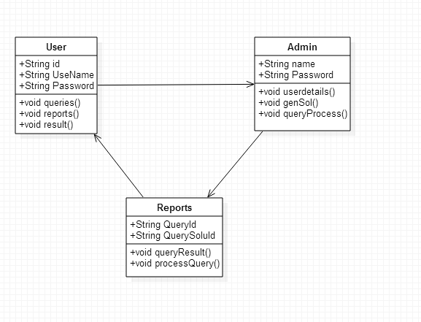

Fig: 3.3.2 Class Diagram

13

    - Sequence Diagram

A sequence diagram in Unified Modeling Language (UML) is a kind of interaction diagram that shows how processes operate with one another and in what order. It is a construct of a Message Sequence Chart.
Sequence diagrams are sometimes called event diagrams, event scenarios, and timing diagrams.

Fig: 3.3.3 Sequence Diagram

14
3.3.4 Flow Chart Diagram

Fig:3.3.4 Flow Chart Diagram

15
CHAPTER-4: INPUT AND OUTPUT DESIGN

4.1 INPUT DESIGN

The input design is the link between the information system and the user. It comprises the developing specification and procedures for data preparation and those steps are necessary to put transaction data in to a usable form for processing can be achieved by inspecting the computer to read data from a written or printed document or it can occur by having people keying the data directly into the system. The design of input focuses on controlling the amount of input required, controlling the errors, avoiding delay, avoiding extra steps and keeping the process simple. The input is designed in such a way so that it provides security and ease of use with retaining the privacy. Input Design considered the following things:
- What data should be given as input?
- How the data should be arranged or coded?
- The dialog to guide the operating personnel in providing input.
- Methods for preparing input validations and steps to follow when error occur.

OBJECTIVES

1.Input Design is the process of converting a user-oriented description of the input into a computer-based system. This design is important to avoid errors in the data input process and show the correct direction to the management for getting correct information from the computerized system.
2. It is achieved by creating user-friendly screens for the data entry to handle large volume of data. The goal of designing input is to make data entry easier and to be free from errors. The data entry screen is designed in such a way that all the data manipulates can be performed. It also provides record viewing facilities.
3.When the data is entered it will check for its validity. Data can be entered with the help of screens.
16

4.2 OUTPUT DESIGN

A quality output is one, which meets the requirements of the end user and presents the information clearly. In any system results of processing are communicated to the users and to other system through outputs. In output design it is determined how the information is to be displaced for immediate need and also the hard copy output. It is the most important and direct source information to the user. Efficient and intelligent output design improves the system’s relationship to help user decision-making.
1. Designing computer output should proceed in an organized, well thought out manner; the right output must be developed while ensuring that each output element is designed so that people will find the system can use easily and effectively. When analysis design computer output, they should Identify the specific output that is needed to meet the requirements.
2.Select methods for presenting information.
3.Create document, report, or other formats that contain information produced by the system.
The output form of an information system should accomplish one or more of the following objectives.
- Convey information about past activities, current status or projections of the
- Future.
- Signal important events, opportunities, problems, or warnings.
- Trigger an action.
- Confirm an action.

17

CHAPTER-5: SOFTWARE ENVIRONMENT

  - Java Technology
Java technology is both a programming language and a platform.
    - The Java Programming Language
The Java programming language is a high-level language that can be characterized by all of the following buzzwords:
      - Simple
      - Architecture neutral
      - Object oriented
      - Portable
      - Distributed
      - High performance
      - Interpreted
      - Multithreaded
      - Robust
      - Dynamic
      - Secure
With most programming languages, you either compile or interpret a program so that you can run it on your computer. The Java programming language is unusual in that a program is both compiled and interpreted. With the compiler, first you translate a program into an intermediate language called Java byte codes —the platform-independent codes interpreted by the interpreter on the Java platform. The interpreter parses and runs each Java byte code instruction on the computer. Compilation happens just once; interpretation occurs each time the program is executed. The following figure illustrates how this works.

18
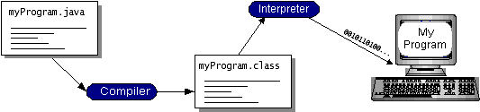

You can think of Java byte codes as the machine code instructions for the Java Virtual Machine (Java VM). Every Java interpreter, whether it’s a development tool or a Web browser that can run applets, is an implementation of the Java VM. Java byte codes help make “write once, run anywhere” possible. You can compile your program into byte codes on any platform that has a Java compiler. The byte codes can then be run on any implementation of the Java VM. That means that as long as a computer has a Java VM, the same program written in the Java programming language can run on Windows 2000, a Solaris workstation, or on an iMac.

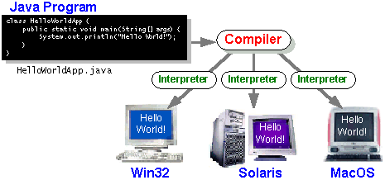

The Java Platform
A platform is the hardware or software environment in which a program runs. We’ve already mentioned some of the most popular platforms like Windows 2000, Linux, Solaris, and MacOS. Most platforms can be described as a combination of the operating system and hardware. The Java platform differs from most other platforms in that it’s a software-only platform that runs on top of other hardware-based platforms.
The Java platform has two components:
19
- The Java Virtual Machine (Java VM)
- The Java Application Programming Interface (Java API)
You’ve already been introduced to the Java VM. It’s the base for the Java platform and is ported onto various hardware-based platforms.
The Java API is a large collection of ready-made software components that provide many useful capabilities, such as graphical user interface (GUI) widgets. The Java API is grouped into libraries of related classes and interfaces; these libraries are known as packages. The next section, What Can Java Technology Do? Highlights what functionality some of the packages in the Java API provide.
The following figure depicts a program that’s running on the Java platform. As the figure shows, the Java API and the virtual machine insulate the program from the hardware.
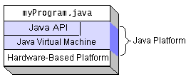
Native code is code that after you compile it, the compiled code runs on a specific hardware platform. As a platform-independent environment, the Java platform can be a bit slower than native code. However, smart compilers, well-tuned interpreters, and just-in-time byte code compilers can bring performance close to that of native code without threatening portability.

What Can Java Technology Do?
The most common types of programs written in the Java programming language are applets and applications. If you’ve surfed the Web, you’re probably already familiar with applets. An applet is a program that adheres to certain conventions that allow it to run within a Java-enabled browser.

20

An application is a standalone program that runs directly on the Java platform. A special kind of application known as a server serves and supports clients on a network. Examples of servers are Web servers, proxy servers, mail servers, and print servers. Another specialized program is a servlet. A servlet can almost be thought of as an applet that runs on the server side. Java Servlets are a popular choice for building interactive web applications, replacing the use of CGI scripts. Servlets are similar to applets in that they are runtime extensions of applications. Instead of working in browsers, though, servlets run within Java Web servers, configuring or tailoring the server.
How does the API support all these kinds of programs? It does so with packages of software components that provides a wide range of functionality. Every full implementation of the Java platform gives you the following features:
- The essentials: Objects, strings, threads, numbers, input and output, data structures, system properties, date and time, and so on.
- Applets: The set of conventions used by applets.
- Networking: URLs, TCP (Transmission Control Protocol), UDP (User Data gram Protocol) sockets, and IP (Internet Protocol) addresses.
- Internationalization: Help for writing programs that can be localized for users worldwide. Programs can automatically adapt to specific locales and be displayed in the appropriate language.
- Security: Both low level and high level, including electronic signatures, public and private key management, access control, and certificates.
- Software components: Known as JavaBeansTM, can plug into existing component architectures.
- Object serialization: Allows lightweight persistence and communication via Remote Method Invocation (RMI).

21
- Java Database Connectivity (JDBCTM): Provides uniform access to a wide range of relational databases.
The Java platform also has APIs for 2D and 3D graphics, accessibility, servers, collaboration, telephony, speech, animation, and more. The following figure depicts what is included in the Java 2 SDK.

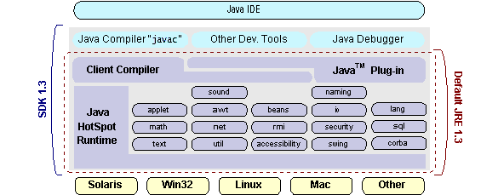

How Will Java Technology Change My Life?
We can’t promise you fame, fortune, or even a job if you learn the Java programming language. Still, it is likely to make your programs better and requires less effort than other languages. We believe that Java technology will help you do the following:
- Get started quickly: Although the Java programming language is a powerful object-oriented language, it’s easy to learn, especially for programmers already familiar with C or C++.
- Write less code: Comparisons of program metrics (class counts, method counts, and so on) suggest that a program written in the Java programming language can be four times smaller than the same program in C++.
- Write better code: The Java programming language encourages good coding practices, and its garbage collection helps you avoid memory leaks. Its object orientation, its JavaBeans component architecture, and its wide-ranging.
22
- Develop programs more quickly: Your development time may be as much as twice as fast versus writing the same program in C++. Why? You write fewer lines of code and it is a simpler programming language than C++.
- Avoid platform dependencies with 100% Pure Java: You can keep your program portable by avoiding the use of libraries written in other languages. The 100% Pure JavaTM Product Certification Program has a repository of historical process manuals, white papers, brochures, and similar materials online.
- Write once, run anywhere: Because 100% Pure Java programs are compiled into machine-independent byte codes, they run consistently on any Java platform.
- Distribute software more easily: You can upgrade applets easily from a central server. Applets take advantage of the feature of allowing new classes to be loaded “on the fly,” without recompiling the entire program.

ODBC
Microsoft Open Database Connectivity (ODBC) is a standard programming interface for application developers and database systems providers. Before ODBC became a de facto standard for Windows programs to interface with database systems, programmers had to use proprietary languages for each database they wanted to connect to. Now, ODBC has made the choice of the database system almost irrelevant from a coding perspective, which is as it should be. Application developers have much more important things to worry about than the syntax that is needed to port their program from one database to another when business needs suddenly change.
Through the ODBC Administrator in Control Panel, you can specify the particular database that is associated with a data source that an ODBC application program is written to use. Think of an ODBC data source as a door with a name on it. Each door will lead you to a particular database. For example, the data source named Sales Figures might be a SQL Server database, whereas the Accounts Payable data source could refer to an Access database. The physical database referred to by a data source can reside anywhere on the LAN.

23
The ODBC system files are not installed on your system by Windows 95. Rather, they are installed when you setup a separate database application, such as SQL Server Client or Visual Basic 4.0. When the ODBC icon is installed in Control Panel, it uses a file called ODBCINST.DLL. It is also possible to administer your ODBC data sources through a stand-alone program called ODBCADM.EXE. There is a 16-bit and a 32-bit version of this program and each maintains a separate list of ODBC data sources.
From a programming perspective, the beauty of ODBC is that the application can be written to use the same set of function calls to interface with any data source, regardless of the database vendor. The source code of the application doesn’t change whether it talks to Oracle or SQL Server. We only mention these two as an example. There are ODBC drivers available for several dozen popular database systems. Even Excel spreadsheets and plain text files can be turned into data sources. The operating system uses the Registry information written by ODBC Administrator to determine which low-level ODBC drivers are needed to talk to the data source (such as the interface to Oracle or SQL Server). The loading of the ODBC drivers is transparent to the ODBC application program. In a client/server environment, the ODBC API even handles many of the network issues for the application programmer.
The advantages of this scheme are so numerous that you are probably thinking there must be some catch. The only disadvantage of ODBC is that it isn’t as efficient as talking directly to the native database interface. ODBC has had many detractors make the charge that it is too slow. Microsoft has always claimed that the critical factor in performance is the quality of the driver software that is used. In our humble opinion, this is true. The availability of good ODBC drivers has improved a great deal recently. And anyway, the criticism about performance is somewhat analogous to those who said that compilers would never match the speed of pure assembly language. Maybe not, but the compiler (or ODBC) gives you the opportunity to write cleaner programs, which means you finish sooner. Meanwhile, computers get faster every year.

24
JDBC
In an effort to set an independent database standard API for Java; Sun Microsystems developed Java Database Connectivity, or JDBC. JDBC offers a generic SQL database access mechanism that provides a consistent interface to a variety of RDBMSs. This consistent interface is achieved through the use of “plug-in” database connectivity modules, or drivers. If a database vendor wishes to have JDBC support, he or she must provide the driver for each platform that the database and Java run on.
To gain a wider acceptance of JDBC, Sun based JDBC’s framework on ODBC. As you discovered earlier in this chapter, ODBC has widespread support on a variety of platforms. Basing JDBC on ODBC will allow vendors to bring JDBC drivers to market much faster than developing a completely new connectivity solution.
JDBC was announced in March of 1996. It was released for a 90 day public review that ended June 8, 1996. Because of user input, the final JDBC v1.0 specification was released soon after.
The remainder of this section will cover enough information about JDBC for you to know what it is about and how to use it effectively. This is by no means a complete overview of JDBC. That would fill an entire book.

JDBC Goals
Few software packages are designed without goals in mind. JDBC is one that, because of its many goals, drove the development of the API. These goals, in conjunction with early reviewer feedback, have finalized the JDBC class library into a solid framework for building database applications in Java.
The goals that were set for JDBC are important. They will give you some insight as to why certain classes and functionalities behave the way they do. The eight design goals for JDBC are as follows:

- SQL Level API
The designers felt that their main goal was to define a SQL interface for Java. Although not the lowest database interface level possible, it is at a low

25
enough level for higher-level tools and APIs to be created. Conversely, it is at
a high enough level for application programmers to use it confidently. Attaining this goal allows for future tool vendors to “generate” JDBC code and to hide many of JDBC’s complexities from the end user.

- SQL Conformance
SQL syntax varies as you move from database vendor to database vendor. In an effort to support a wide variety of vendors, JDBC will allow any query statement to be passed through it to the underlying database driver. This allows the connectivity module to handle non-standard functionality in a manner that is suitable for its users.
- JDBC must be implemental on top of common database interfaces
The JDBC SQL API must “sit” on top of other common SQL level APIs. This goal allows JDBC to use existing ODBC level drivers by the use of a software interface. This interface would translate JDBC calls to ODBC and vice versa.
- Provide a Java interface that is consistent with the rest of the Java system
Because of Java’s acceptance in the user community thus far, the designers feel that they should not stray from the current design of the core Java system.
- Keep it simple
This goal probably appears in all software design goal listings. JDBC is no exception. Sun felt that the design of JDBC should be very simple, allowing for only one method of completing a task per mechanism. Allowing duplicate functionality only serves to confuse the users of the API.
- Use strong, static typing wherever possible
Strong typing allows for more error checking to be done at compile time; also, less error appear at runtime.
- Keep the common cases simple
Because more often than not, the usual SQL calls used by the programmer are simple SELECT’s, INSERT’s, DELETE’s and UPDATE’s, these queries should be simple to perform with JDBC.
26
However, more complex SQL statements should also be possible.
Finally we decided to proceed the implementation using Java Networking.
And for dynamically updating the cache table we go for MS Access database.

Java ha two things: a programming language and a platform.

Java is a high-level programming language that is all of the following

Simple Architecture-neutral

Object-oriented Portable

Distributed High-performance

Interpreted multithreaded

Robust Dynamic

Secure

Java is also unusual in that each Java program is both compiled and interpreted. With a compile you translate a Java program into an intermediate language called Java byte codes the platform-independent code instruction is passed and run on the computer.

Compilation happens just once; interpretation occurs each time the program is executed. The figure illustrates how this works.

27
Java Program

Compilers

Interpreter

My Program

You can think of Java byte codes as the machine code instructions for the Java Virtual Machine (Java VM). Every Java interpreter, whether it’s a Java development tool or a Web browser that can run Java applets, is an implementation of the Java VM. The Java VM can also be implemented in hardware.

Java byte codes help make “write once, run anywhere” possible. You can compile your Java program into byte codes on my platform that has a Java compiler. The byte codes can then be run any implementation of the Java VM. For example, the same Java program can run Windows NT, Solaris, and Macintosh.

28

Networking

TCP/IP stack
The TCP/IP stack is shorter tha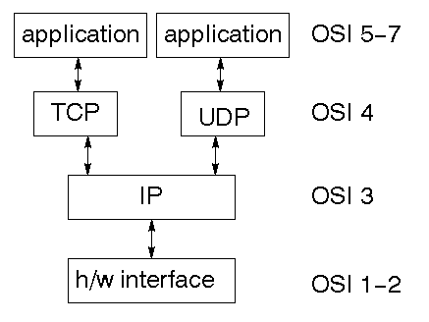n the OSI one:

TCP is a connection-oriented protocol; UDP (User Datagram Protocol) is a connectionless protocol.
IP datagram’s
The IP layer provides a connectionless and unreliable delivery system. It considers each datagram independently of the others. Any association between datagram must be supplied by the higher layers. The IP layer supplies a checksum that includes its own header. The header includes the source and destination addresses. The IP layer handles routing through an Internet. It is also responsible for breaking up large datagram into smaller ones for transmission and reassembling them at the other end.

29

UDP
UDP is also connectionless and unreliable. What it adds to IP is a checksum for the contents of the datagram and port numbers. These are used to give a client/server model - see later.

TCP
TCP supplies logic to give a reliable connection-oriented protocol above IP. It provides a virtual circuit that two processes can use to communicate.

Internet addresses
In order to use a service, you must be able to find it. The Internet uses an address scheme for machines so that they can be located. The address is a 32 bit integer which gives the IP address. This encodes a network ID and more addressing. The network ID falls into various classes according to the size of the network address.

Network address
Class A uses 8 bits for the network address with 24 bits left over for other addressing. Class B uses 16 bit network addressing. Class C uses 24 bit network addressing and class D uses all 32.

Subnet address
Internally, the UNIX network is divided into sub networks. Building 11 is currently on one sub network and uses 10-bit addressing, allowing 1024 different hosts.

Host address
8 bits are finally used for host addresses within our subnet. This places a limit of 256 machines that can be on the subnet.

30

Total address

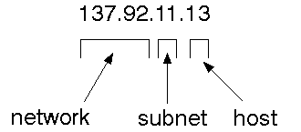
The 32 bit address is usually written as 4 integers separated by dots.

Port addresses
A service exists on a host, and is identified by its port. This is a 16 bit number. To send a message to a server, you send it to the port for that service of the host that it is running on. This is not location transparency! Certain of these ports are "well known".

Sockets
A socket is a data structure maintained by the system to handle network connections. A socket is created using the call socket. It returns an integer that is like a file descriptor. In fact, under Windows, this handle can be used with Read File and Write File functions.
#include <sys/types.h>
#include <sys/socket.h>
int socket(int family, int type, int protocol);
Here "family" will be AF_INET for IP communications, protocol will be zero, and type will depend on whether TCP or UDP is used. Two processes wishing to communicate over a network create a socket each. These are similar to two ends of a pipe - but the actual pipe does not yet exist.
31
JFree Chart
JFreeChart is a free 100% Java chart library that makes it easy for developers to display professional quality charts in their applications. JFreeChart's extensive feature set includes:
A consistent and well-documented API, supporting a wide range of chart types;
A flexible design that is easy to extend, and targets both server-side and client-side applications;
Support for many output types, including Swing components, image files (including PNG and JPEG), and vector graphics file formats (including PDF, EPS and SVG);
JFreeChart is "open source" or, more specifically, free software. It is distributed under the terms of the GNU Lesser General Public Licence (LGPL), which permits use in proprietary applications.

1. Map Visualizations
Charts showing values that relate to geographical areas. Some examples include: (a) population density in each state of the United States, (b) income per capita for each country in Europe, (c) life expectancy in each country of the world. The tasks in this project include:
Sourcing freely redistributable vector outlines for the countries of the world, states/provinces in particular countries (USA in particular, but also other areas);
Creating an appropriate dataset interface (plus default implementation), a rendered, and integrating this with the existing XYPlot class in JFreeChart;
Testing, documenting, testing some more, documenting some more.

2. Time Series Chart Interactivity
Implement a new (to JFreeChart) feature for interactive time series charts --- to display a separate control that shows a small version of ALL the time series data, with a sliding "view" rectangle that allows you to select the subset of the time series data to display in the main chart.

32

3. Dashboards
There is currently a lot of interest in dashboard displays. Create a flexible dashboard mechanism that supports a subset of JFreeChart chart types (dials, pies, thermometers, bars, and lines/time series) that can be delivered easily via both Java Web Start and an applet.

4. Property Editors
The property editor mechanism in JFreeChart only handles a small subset of the properties that can be set for charts. Extend (or reimplement) this mechanism to provide greater end-user control over the appearance of the charts

Tomcat 6.0 web server
Tomcat is an open source web server developed by Apache Group. Apache Tomcat is the servlet container that is used in the official Reference Implementation for the Java Servlet and JavaServer Pages technologies. The Java Servlet and JavaServer Pages specifications are developed by Sun under the Java Community Process. Web Servers like Apache Tomcat support only web components while an application server supports web components as well as business components (BEAs Weblogic, is one of the popular application server).To develop a web application with jsp/servlet install any web server like JRun, Tomcat etc to run your application.

33
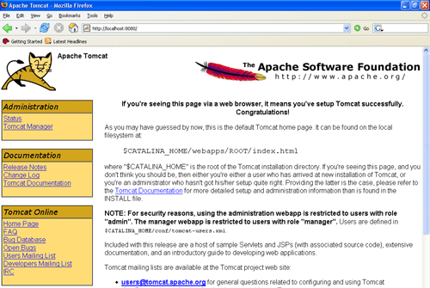

Fig Tomcat Webserver

34

CHAPTER6: SYSTEM STUDY
FEASIBILITY STUDY
The feasibility of the project is analyzed in this phase and business proposal is put forth with a very general plan for the project and some cost estimates. During system analysis the feasibility study of the proposed system is to be carried out. This is to ensure that the proposed system is not a burden to the company. For feasibility analysis, some understanding of the major requirements for the system is essential.
Three key considerations involved in the feasibility analysis are

      - ECONOMICAL FEASIBILITY

      - TECHNICAL FEASIBILITY

      - SOCIAL FEASIBILITY

6.1 ECONOMICAL FEASIBILITY

This study is carried out to check the economic impact that the system
will have on the organization. The amount of fund that the company can pour into the research and development of the system is limited. The expenditures must be justified. Thus the developed system as well within the budget and this was achieved because most of the technologies used are freely available. Only the customized products had to be purchased.
6.2 TECHNICAL FEASIBILITY

This study is carried out to check the technical feasibility, that is, the technical requirements of the system. Any system developed must not have a high demand on the available technical resources. This will lead to high demands on the available technical resources. This will lead to high demands being placed on the client. The developed system must have a modest requirement, as only minimal or null changes are required for implementing this system.

35
  - SOCIAL FEASIBILITY

The aspect of study is to check the level of acceptance of the system by the user. This includes the process of training the user to use the system efficiently. The user must not feel threatened by the system, instead must accept it as a necessity. The level of acceptance by the users solely depends on the methods that are employed to educate the user about the system and to make him familiar with it. His level of confidence must be raised so that he is also able to make some constructive criticism, which is welcomed, as he is the final user of the system.

36

CHAPTER-7: SYSTEM TESTING

The purpose of testing is to discover errors. Testing is the process of trying to discover every conceivable fault or weakness in a work product. It provides a way to check the functionality of components, sub assemblies, assemblies and/or a finished product It is the process of exercising software with the intent of ensuring that the Software system meets its requirements and user expectations and does not fail in an unacceptable manner. There are various types of tests. Each test type addresses a specific testing requirement.

7.1 TYPES OF TESTS

    - Unit testing

Unit testing involves the design of test cases that validate that the internal program logic is functioning properly, and that program inputs produce valid outputs. All decision branches and internal code flow should be validated. It is the testing of individual software units of the application .it is done after the completion of an individual unit before integration. This is a structural testing, that relies on knowledge of its construction and is invasive. Unit tests perform basic tests at component level and test a specific business process, application, and/or system configuration. Unit tests ensure that each unique path of a business process performs accurately to the documented specifications and contains clearly defined inputs and expected results.

7.1.2 Integration testing
Integration tests are designed to test integrated software components to determine if they actually run as one program. Testing is event driven and is more concerned with the basic outcome of screens or fields. Integration tests demonstrate that although the components were individually satisfaction, as shown by successfully unit testing, the combination of components is correct and consistent.
37
Integration testing is specifically aimed at exposing the problems that arise from the combination of components.

7.1.3 Functional test
Functional tests provide systematic demonstrations that functions tested are available as specified by the business and technical requirements, system documentation, and user manuals.
Functional testing is centered on the following items:
Valid Input : identified classes of valid input must be accepted.
Invalid Input : identified classes of invalid input must be rejected.
Functions : identified functions must be exercised.
Output : identified classes of application outputs must be exercised.
Systems/Procedures: interfacing systems or procedures must be invoked.
Organization and preparation of functional tests is focused on requirements, key functions, or special test cases. In addition, systematic coverage pertaining to identify Business process flows; data fields, predefined processes, and successive processes must be considered for testing. Before functional testing is complete, additional tests are identified and the effective value of current tests is determined.

7.1.4 System Test
System testing ensures that the entire integrated software system meets requirements. It tests a configuration to ensure known and predictable results. An example of system testing is the configuration oriented system integration test. System testing is based on process descriptions and flows, emphasizing pre-driven process links and integration points.

White Box Testing
White Box Testing is a testing in which in which the software tester has knowledge of the inner workings, structure and language of the software, or at least its purpose.
38

Black Box Testing
Black Box Testing is testing the software without any knowledge of the inner workings, structure or language of the module being tested. Black box tests, as most other kinds of tests, must be written from a definitive source document, such as specification or requirements document, such as specification or requirements document. It is a testing in which the software under test is treated, as a black box .you cannot “see” into it. The test provides inputs and responds to outputs without considering how the software works.

Unit Testing:
Unit testing is usually conducted as part of a combined code and unit test phase of the software lifecycle, although it is not uncommon for coding and unit testing to be conducted as two distinct phases.

Test strategy and approach
Field testing will be performed manually and functional tests will be written in detail.

Test objectives
- All field entries must work properly.
- Pages must be activated from the identified link.
- The entry screen, messages and responses must not be delayed.

Features to be tested
- Verify that the entries are of the correct format
- No duplicate entries should be allowed
- All links should take the user to the correct page.
Integration Testing
Software integration testing is the incremental integration testing of two or more integrated software components on a single platform to produce failures caused by interface defects.

39

The task of the integration test is to check that components or software applications, e.g. components in a software system or – one step up – software applications at the company level – interact without error.

Test Results: All the test cases mentioned above passed successfully. No defects encountered.

7.1.5 Acceptance Testing

User Acceptance Testing is a critical phase of any project and requires significant participation by the end user. It also ensures that the system meets the functional requirements.
Test Results: All the test cases mentioned above passed successfully. No defects encountered.

40

CHAPTER-8: RESULTS

  - Home Page

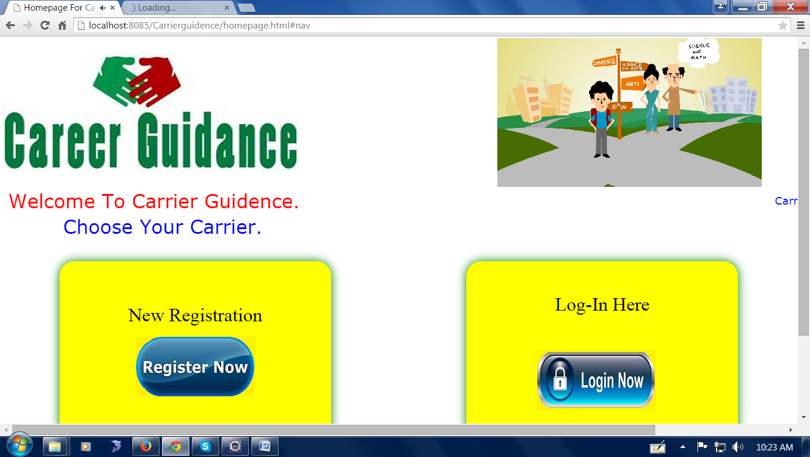
Fig:8.1 Screenshot of Home Page

  - User Login Page

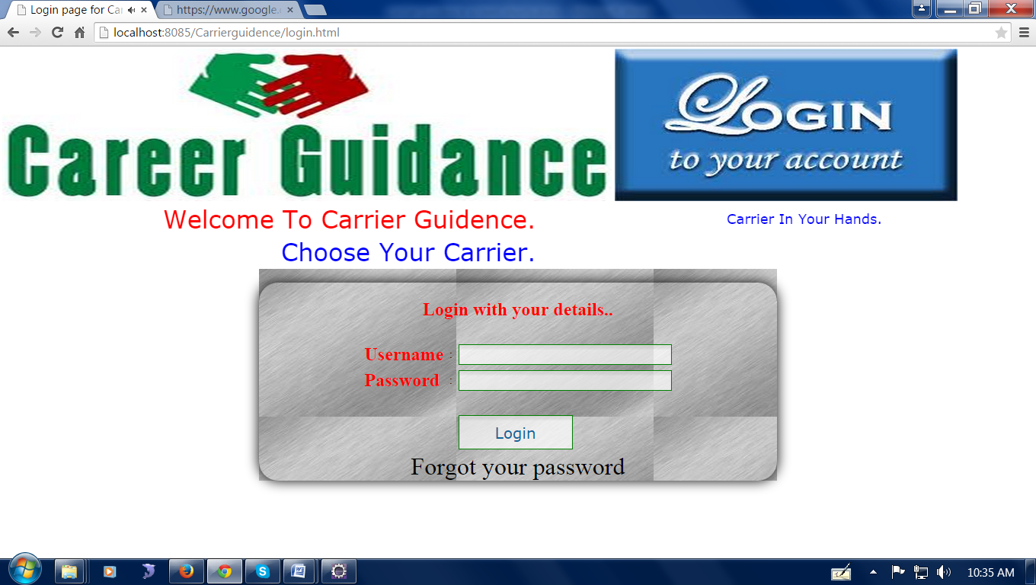
Fig:8.2 Screenshot of User Login Page

41

  - User Registration

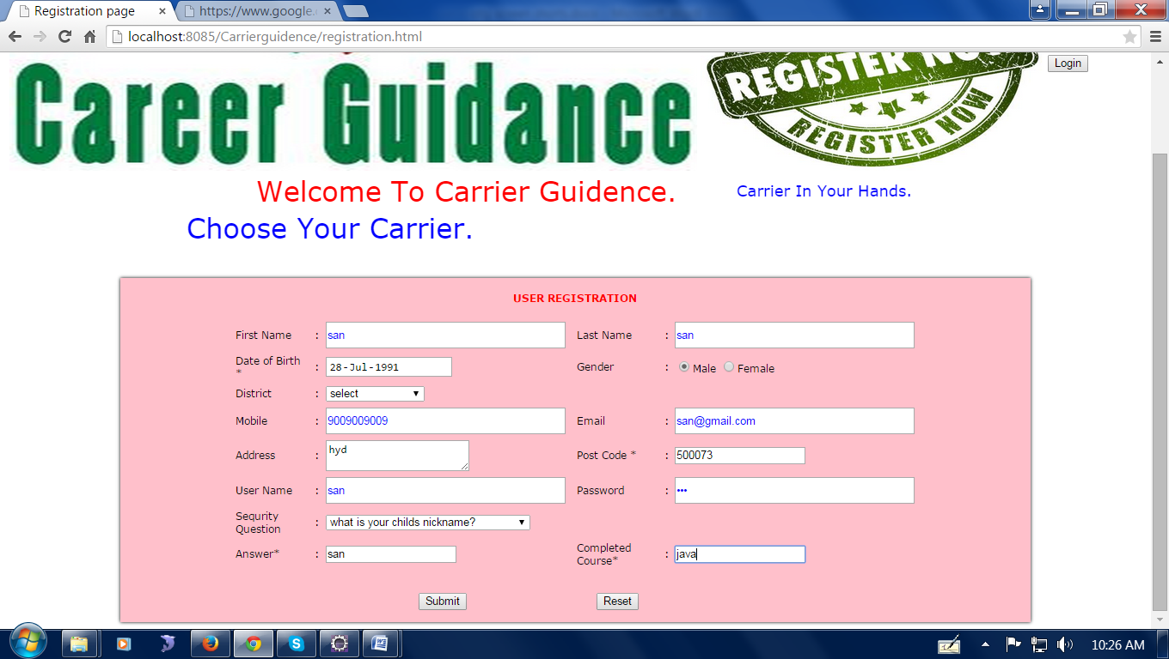
Fig8.3 Screenshot of User Registration

  - Course Informaton

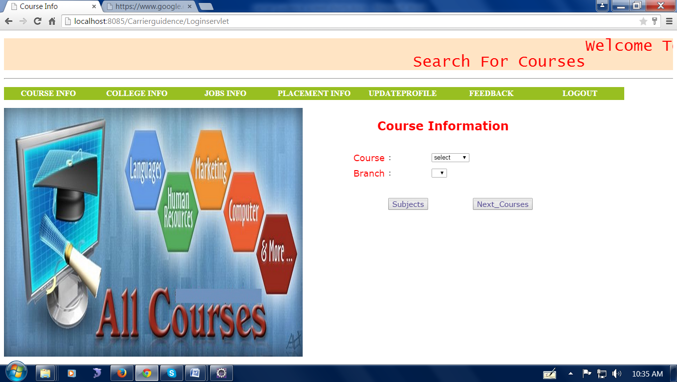
Fig:8.4 Screenshot of Course Information

42

  - List of Courses

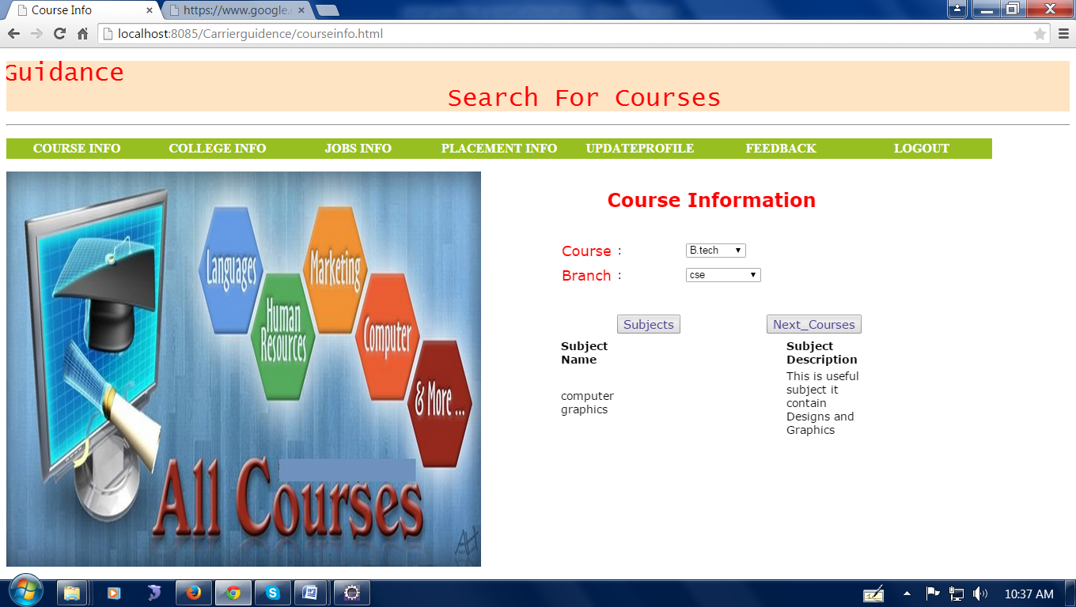
Fig:8.5 Screenshot of List of Courses

  - Job Information

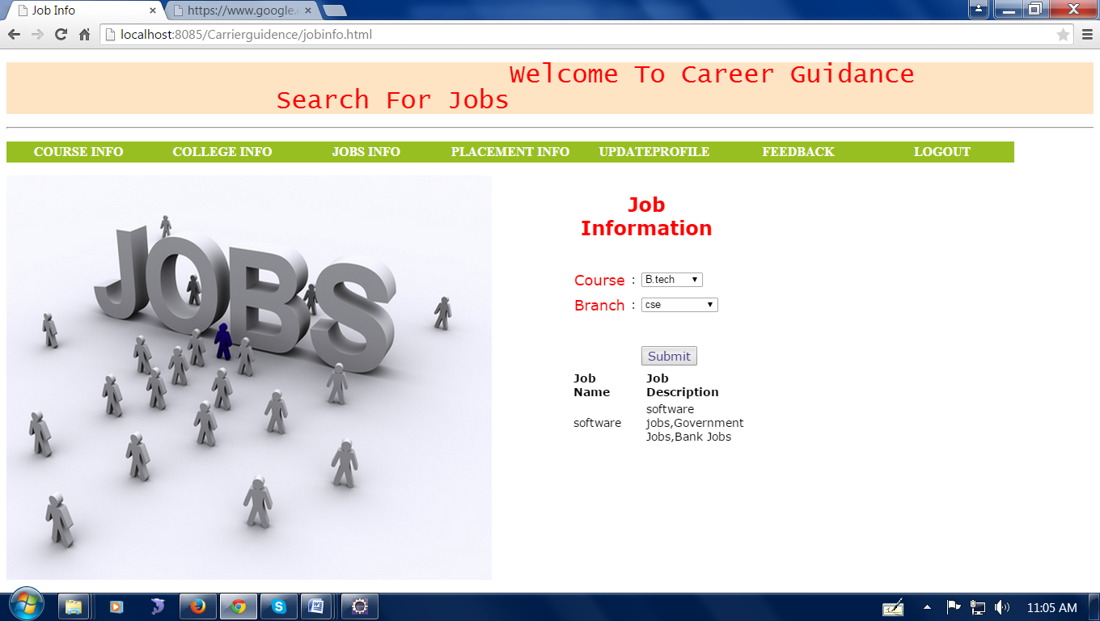
Fig:8.6 Screenshot of Job Information

43

  - Placement Details

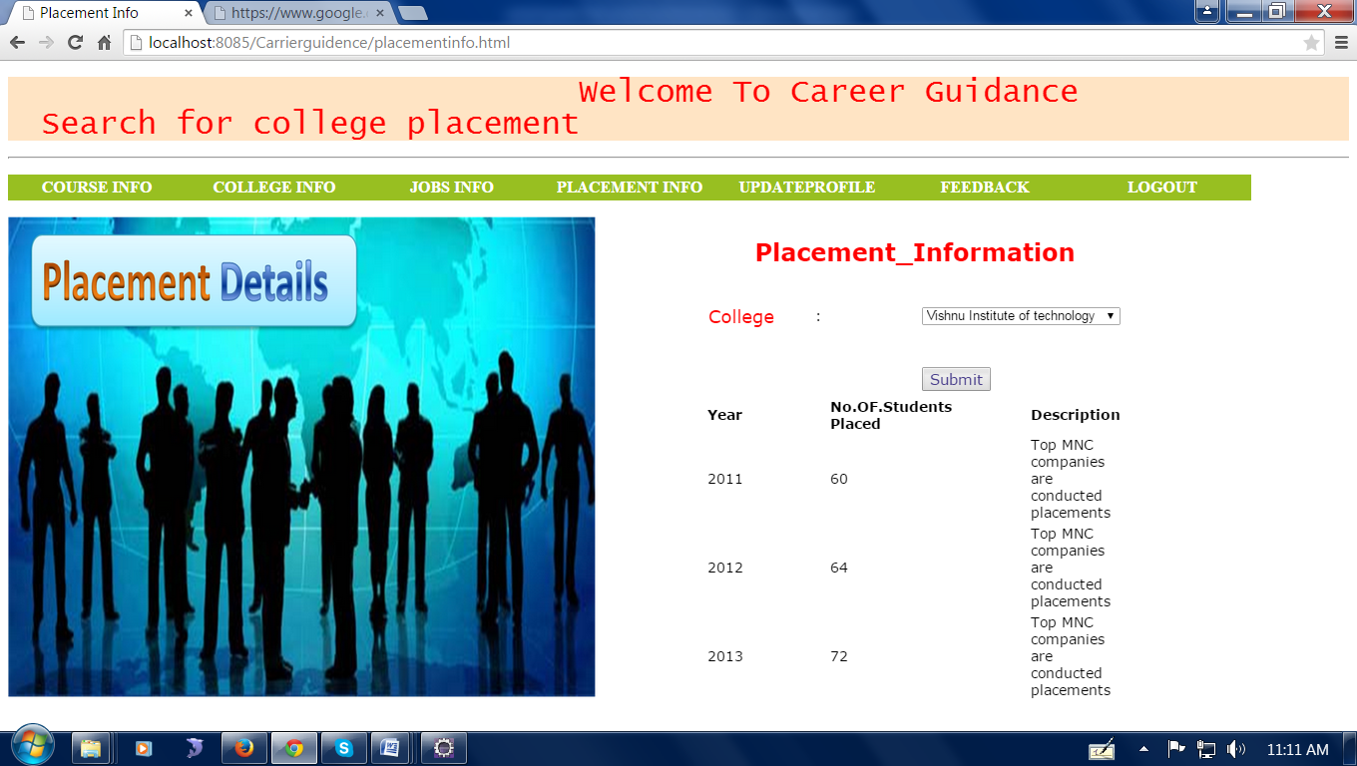
Fig:8.7 Screenshot of Placement Details

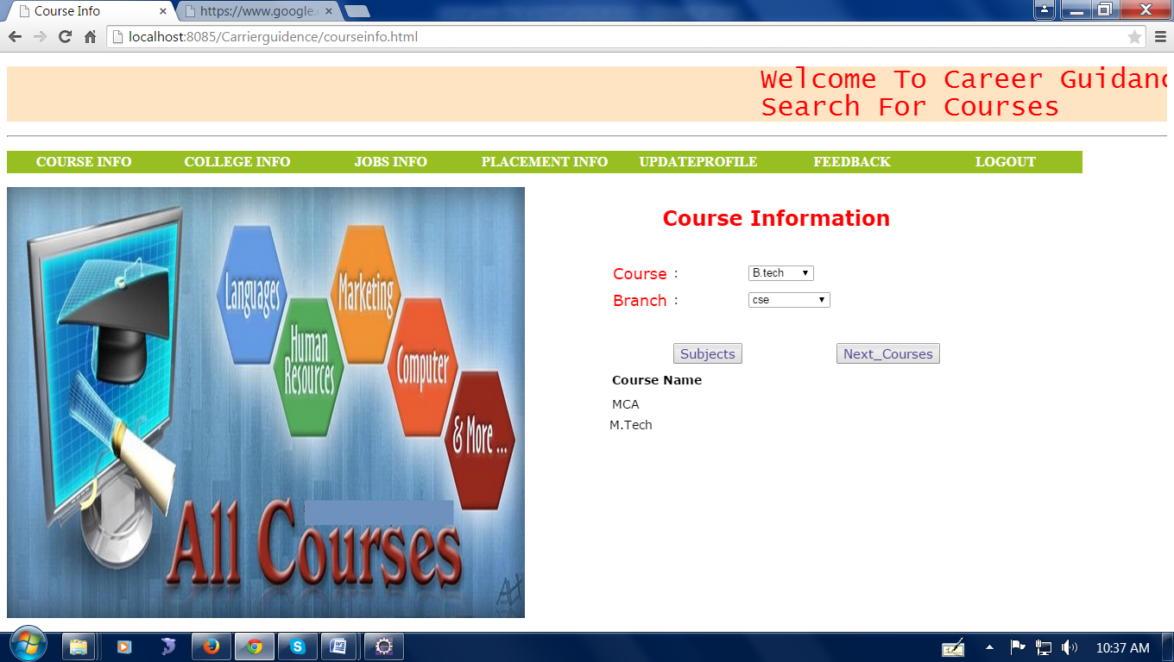
Fig:8.8

44
  - Feedback form

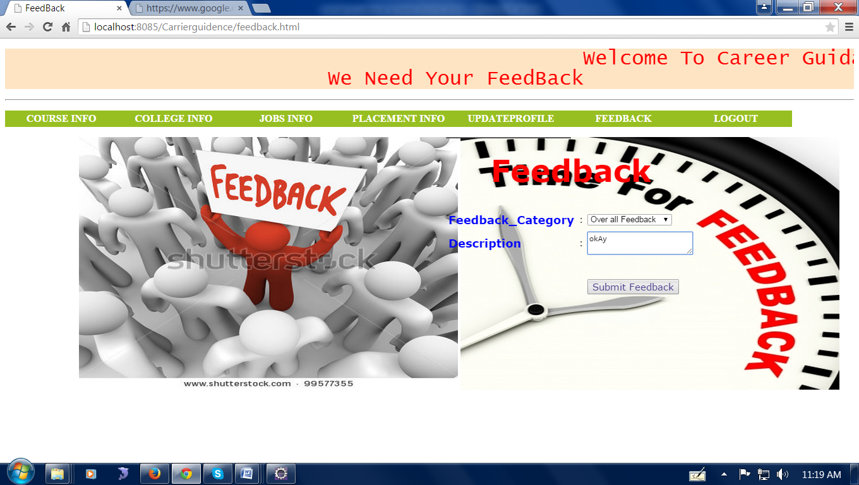
Fig:8.9 Screenshot of Feedback form

  - Forgot Password

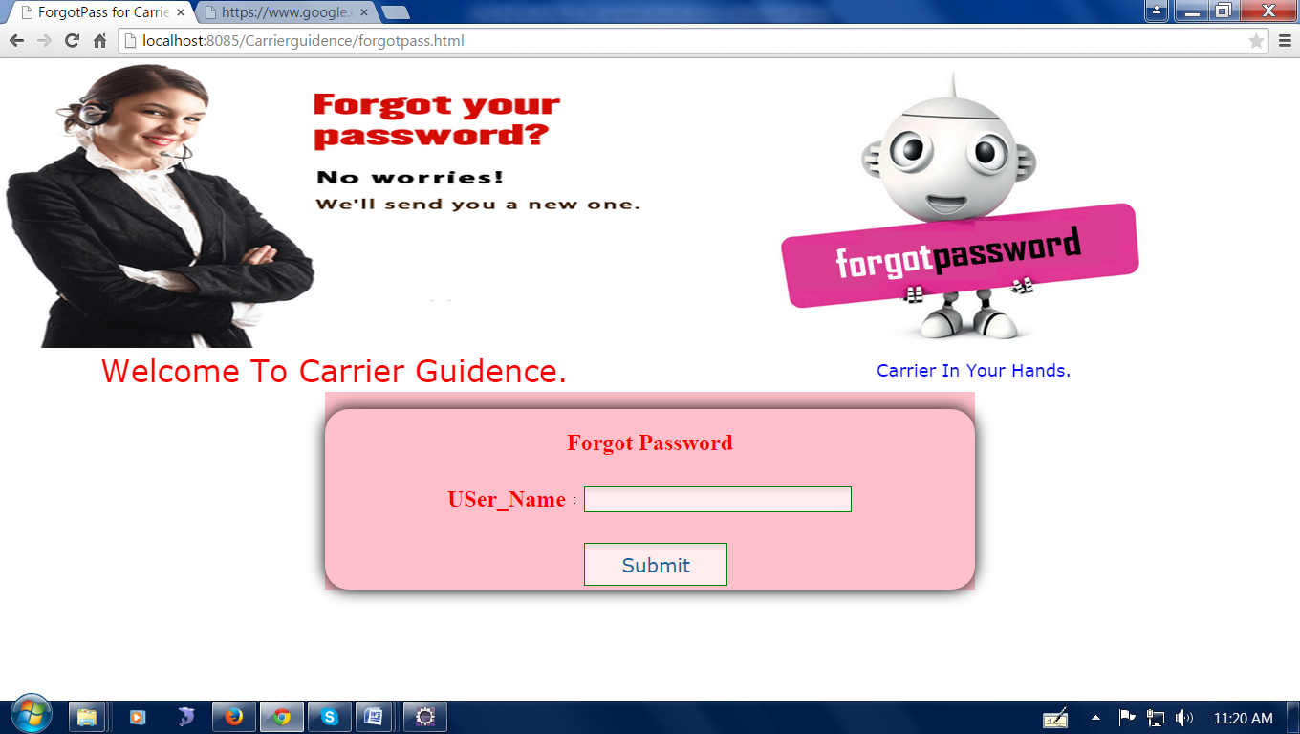
Fig:8.10 Screenshot of Forgot Password

45

CHAPTER 9:CONCLUSION & FUTURE ENHANCEMENT

CONCLUSION:
Career guidance in education is crucial for empowering students to make informed decisions about their futures. It helps them understand their interests, strengths, and potential career paths, thereby aligning their educational pursuits with their long-term goals. By providing these resources, educational institutions can ensure that students are better prepared to enter the workforce, pursue higher education, or embark on entrepreneurial ventures, ultimately leading to more fulfilling and successful careers.
This platform will remain instrumental in fostering career growth, facilitating lifelong learning, and empowering individuals to pursue fulfilling and impactful careers in education.

FUTURE ENHANCEMENT:
In envisioning the future of online career guidance for education, several enhancements can be implemented to further enrich user experiences and support career development. Integrating cutting-edge technologies like Artificial Intelligence and Machine Learning can enable personalized career recommendations based on user data and market trends. Augmented and Virtual Reality experiences can offer immersive glimpses into educational environments, enhancing career exploration. Strengthened mentorship programs and peer networks foster valuable connections and guidanceReal-time labor market analytics empower users with up-to-date insights. Mobile app development enhances accessibility and convenience, while multilingual support expands global reachBy embracing these advancements, online career guidance platforms can evolve into dynamic ecosystems, empowering individuals to navigate and thrive in diverse education careers.

46
Top of Form
Bottom of Form

CHAPTER10.BIBLIOGRAPHY

[1] Dr. Tricia Seifert, Arnold, C., Burrow, J., Brown, A., & Bruce, C. (2014). How College Affects Students: Findings and Insights from Twenty Years of Research. Jossey-Bass. "Understanding the Impact of Involvement in High-Impact Educational Practices." Journal of College Student Development, 54(5), 465-479.
[2] Dr. Emily Porschitz, E., & Smith, J. (2020). "Exploring New Frontiers in Educational Technology." Journal of Educational Technology Research, 45(2), 123-137. "The Impact of Digital Literacy on Student Engagement."
[3] Dr. Deirdre Hughes, D., & Karp, M. M. (2004). "From School to Work: Rethinking the Transition." Journal of Vocational Education and Training, 56(1), 5-20, Green, A. (2013). Managing Transitions: Support for Individuals at Key Points of Change. Routledge.
[4] Dr. Wendy Patton, W., & McMahon, M. (2006). Career Development and Systems Theory: Connecting Theory and Practice. Sense Publishers. McMahon, M. (2014). Career Development and Systems Theory: A New Relationship. Sense Publishers.
[5] Dr. Mark Savickas ,Career Counseling. American Psychological Association. In R. W. Lent & S. D. Brown (Eds.), Career Development and Counseling: Putting Theory and Research to Work (2nd ed., pp. 147-183). Wiley.
[6] Dr. Jane Goodman, J., Schlossberg, N. K., & Anderson, M. L. (2006). Counseling Adults in Transition: J., & Hansen. "Translation as a Tool for Language Revitalization: Berber Radio in Algeria". Language & Communication, 34(1), 45-57.
[7] Frank Parsons, Houghton Mifflin.Parsons, F. (1908). "The Vocational Bureau: Its Work and Principles."
47
The Arena, 39, 133-142.In this article, Parsons describes the establishment and functioning of the Vocational Bureau of Boston.
[8] John Holland, Holland, J. L. (1959). "A Theory of Vocational Choice." Journal of Counseling Psychology, 6(1), Holland, J. L. (1997). Making Vocational Choices: A Theory of Vocational Personalities and Work Environments (3rd ed pp107-123) Psychological Assessment Resources.
[9] Dr.Albert Bandura, Social Learning Theory. Prentice-Hall.This book introduces Bandura's social learning theory, emphasizing the role of observational learning, imitation and development. Bandura, A. (1986). Social Foundations of Thought and Action: A Social Cognitive Theory. Prentice-Hall.
[10] Norman Gysbers, Developing and Managing Your School Guidance and Counseling Program (4th ed.). American Counseling Association. Gysbers, N. C., Heppner, M. J., & Johnston, J. A. (2014). Career Counseling: Holism, Diversity, and Strengths (4th ed.). American Counseling Association.

48

